Vercel or Render

--

Render

**⚠️ Vercel is not optimized for Python/Flask by default**

Vercel is designed primarily for **Node.js**, **Next.js**, **React**, etc.

However, **you *can* deploy Flask** using:

* **Serverless functions via Python** (using Vercel's experimental Python support)
* **Or better:** deploy Flask to **Render.com**, **Fly.io**, or **Railway.app**

**Recommended: Deploy Flask to Render.com (easy + free)**

**🔧 Steps:**

1. ✅ Push your Flask project to a **GitHub repo**
2. 🔗 Go to <https://render.com>
3. Click **"New Web Service"**
4. Choose:
   * **Python**
   * GitHub repo with your Flask app
   * start command: gunicorn app:app
   * build command: pip install -r requirements.txt
   * Environment: Python 3.11 (or your version)
5. Click Deploy

🚀 That’s it — Render will host your Flask chatbot with a public HTTPS URL.

Dashboard.render.com

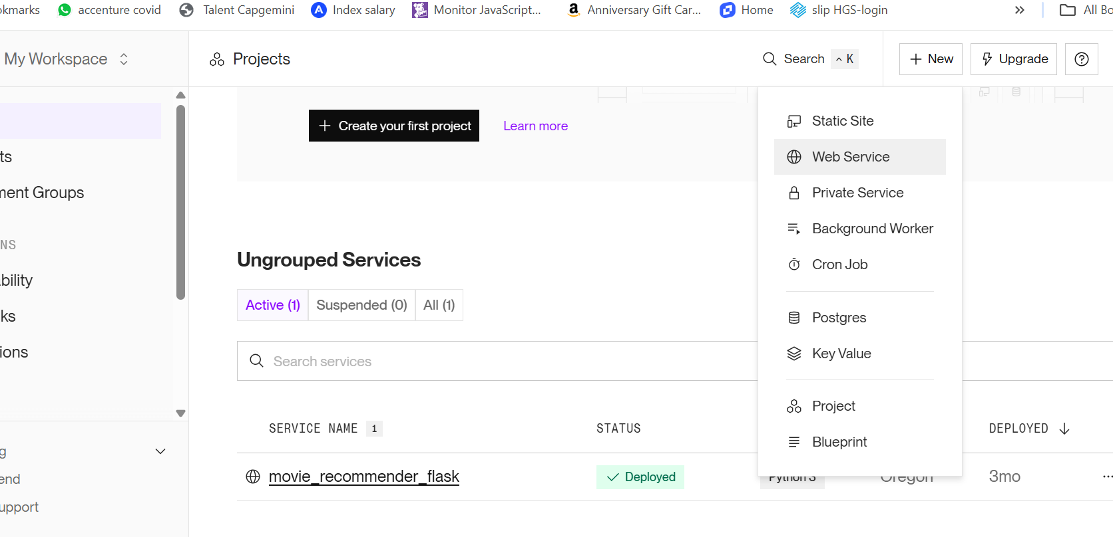

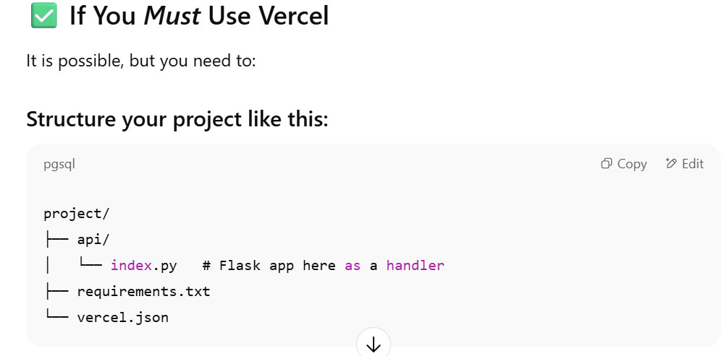

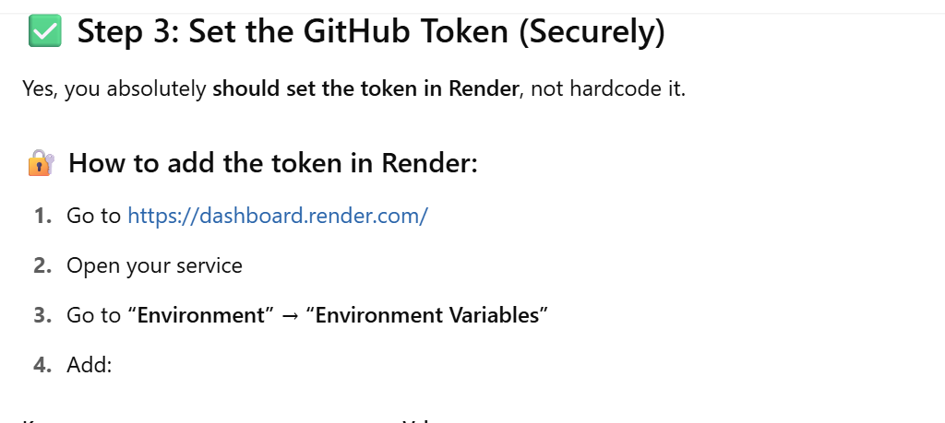

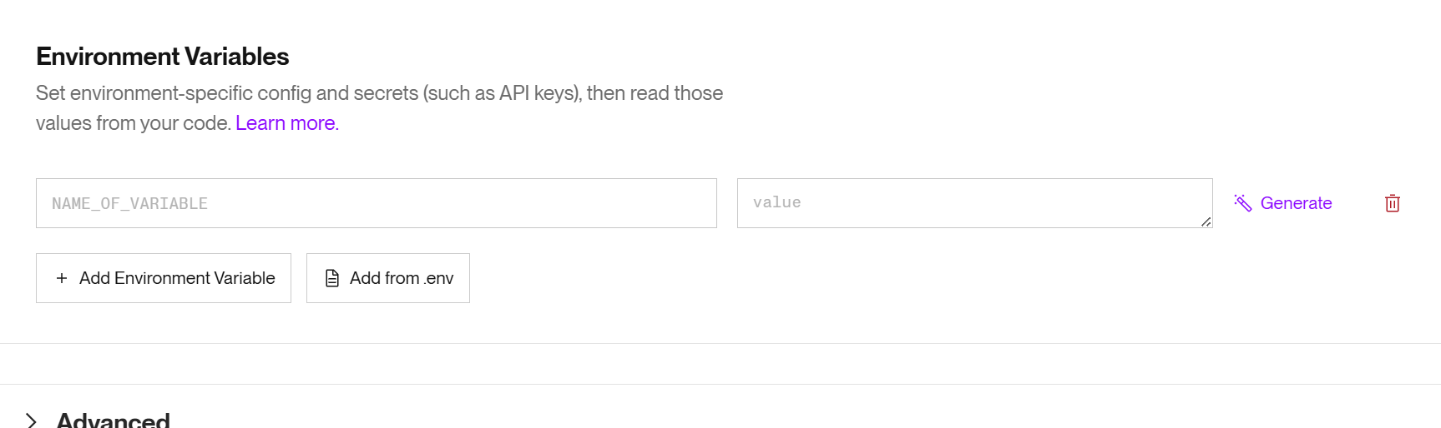



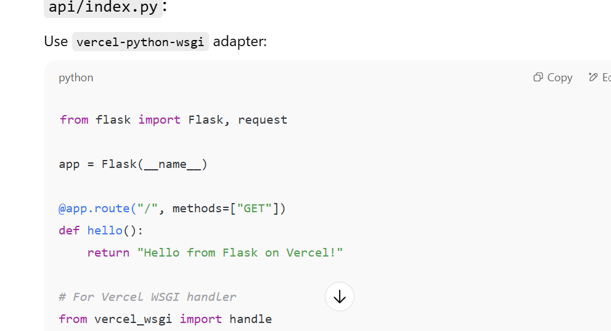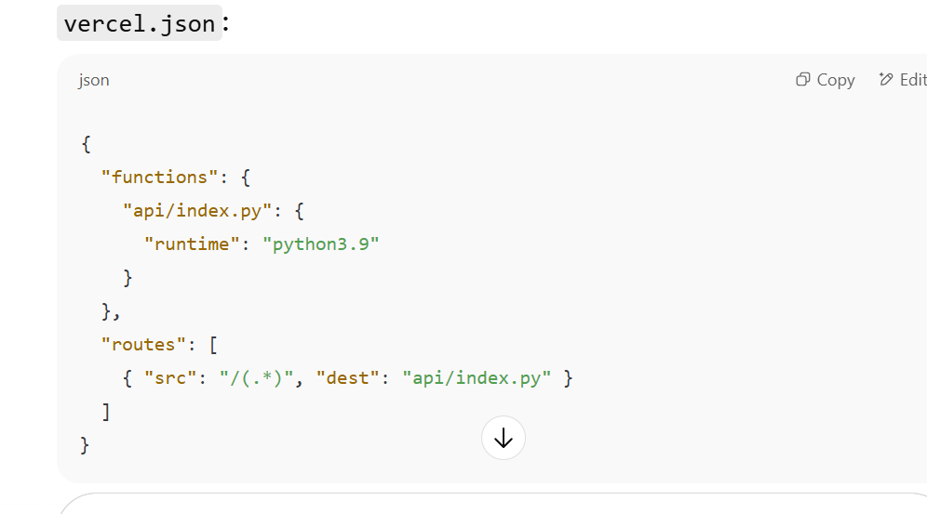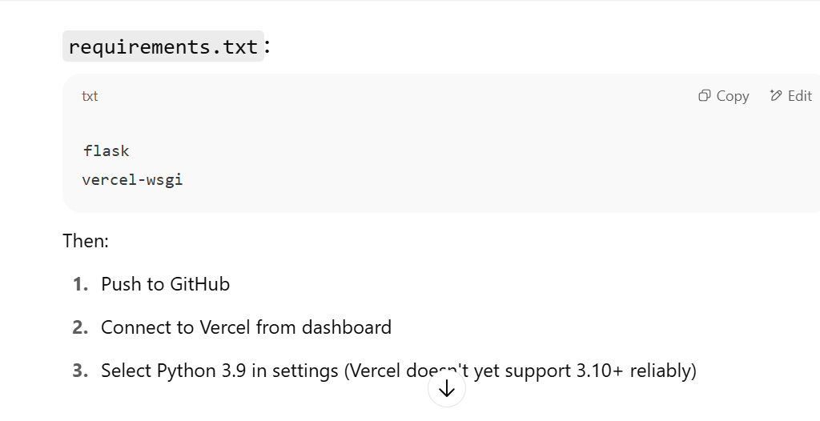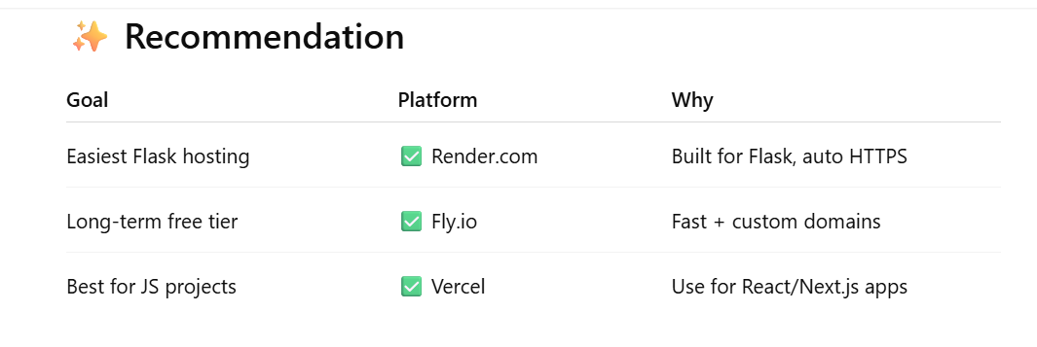

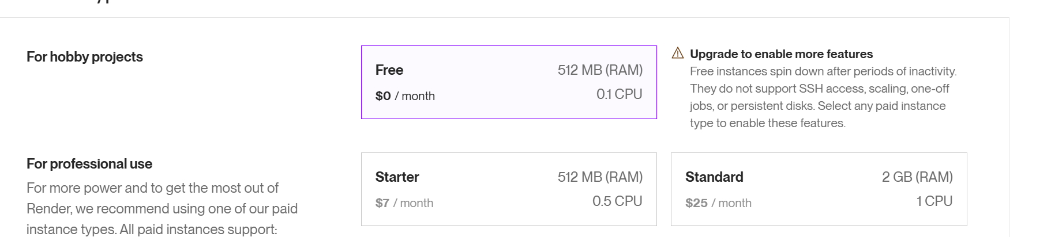

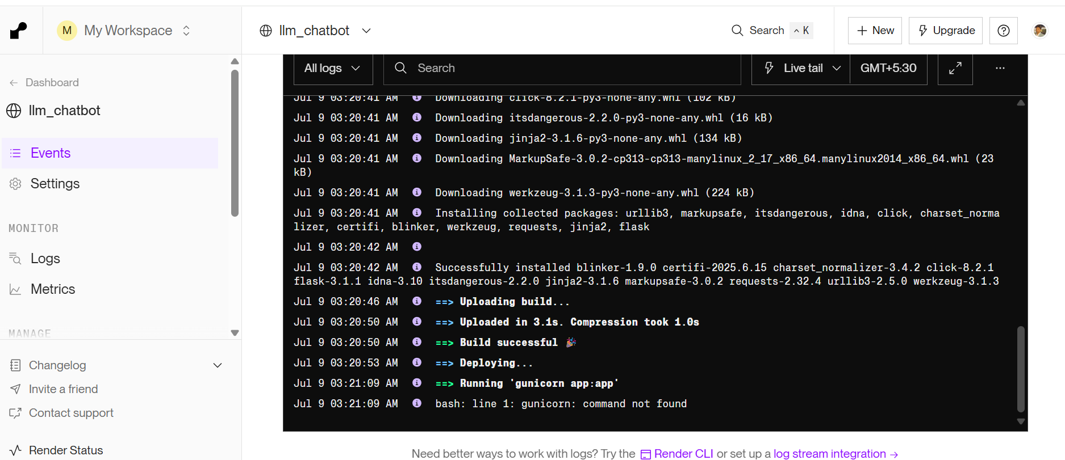

Render will automatically trigger a redeploy. ✅

**✅ Why Gunicorn?**

* Render uses gunicorn as a production WSGI server.
* flask run is good for local dev, but not reliable for production.

pip install -r requirements.txt

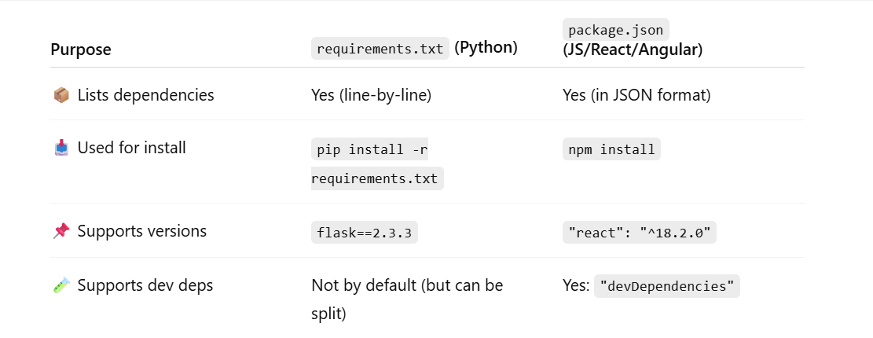

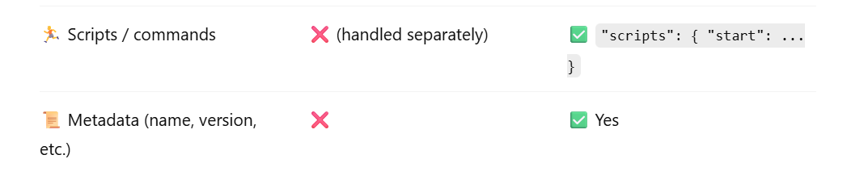**TL;DR**

* requirements.txt → Only dependencies, plain text
* package.json → Dependencies **+** metadata **+** scripts, in JSON

**pyproject.toml (modern Python projects)**

It's like the next-gen package.json for Python, used by poetry, pdm, or pip.